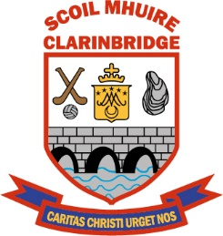 **SCOIL MHUIRE CLARINBRIDGE**

**ANNUAL ADMISSION NOTICE**

**in respect of admissions to the 2026/2027 school year**

**Admission Policy and Application Form**

A copy of the school’s **Admission Policy** and the **Application Form for Admission** (when the application period begins) for the 2026/2027 school year is available as follows: –

To download at: [www.clarinbridgeschool.ie](http://www.clarinbridgeschool.ie) Click on the Enrolment or Download Tabs

On request: By emailing [info@clarinbridgeschool.ie](mailto:info@clarinbridgeschool.ie)

Or writing to: School Office, Scoil Mhuire, Clarinbridge, Co. Galway H91 D7P3

**PART 1 - Admissions to the 2026/ 2027 school year**

**Application and Decision Dates for admission to the 2026/ 2027 school year** The following are the dates applicable for admission to the Junior Infants Class.

|  |  |
| --- | --- |
| The school will commence accepting applications for admission on Tuesday 21st October 2025. | **21.10.2025** |
| The school shall cease accepting applications for admission on Tuesday 11th November 2025. | **11.11.2025** |
| The date by which applicants will be notified of the decision on their application is Wednesday 19th November 2025 | **19.11.2025** |
| The period within which applicants must confirm acceptance of an offer of admission is no later than Tuesday 2nd December 2025. | **02.12.2025** |

**\*Failure to accept an offer within the prescribed period above may result in the offer being withdrawn**

**Note: the school will consider and issue decisions on late applications in accordance with the school’s Admission Policy.**

**Number of places being made available for Junior Infants in the 2026 / 2027 school year**

|  |  |
| --- | --- |
| The number of places being made available in Junior Infants is | **34** |